Department of Energy, Environment and Climate Action
Position Description
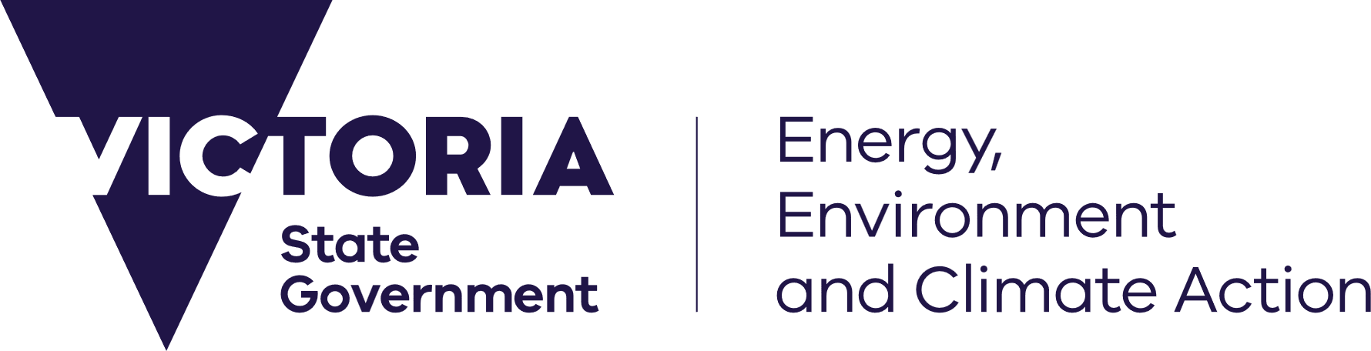


Position Details
Position title: | Licensing Support Officer
Position number: | 50967656
Classification: | VPS Grade 3
Salary range: | $79,122 - $96,073 plus superannuation
Employment type: | Ongoing
Group: | Resources Victoria
Division & Branch: | Regulatory Operations
Work location: | 8 Nicholson Street, Melbourne  Hybrid work arrangement available: Yes No
Reports to: | Manager, Petroleum Authorisations
Direct reports: | Yes No If yes, how many?
Further information: | Vilma Pabilionyte, Senior Petroleum Licensing Officer: (03) 8508 1928
Position purpose
The Licensing Support Officer (LSO) provides administrative and licensing support to the team, ensuring accurate administration of applications, maintenance of records and document and data management. The LSO also contributes to the preparation of briefings, reports, and responses to internal and external stakeholders.
Context
Resources Victoria’s mission is to facilitate informed and responsible earth resources exploration, development, extraction and rehabilitation in Victoria. This includes oversight of mining activities for critical minerals, gold and other metals, petroleum, coal, sand, rock and gravel.

Our priorities are to:
- Increase investment in Victoria’s earth resources, including new critical minerals.
- Build confidence in the performance of the earth resources sector in Victoria and its regulation.
- Secure the supply of quarry materials essential for new infrastructure.

We will deliver this by:
- Applying our specialist scientific and technical expertise to understand Victoria’s geology and create new opportunities for responsible investment.
- Delivering resources policy and legislative reform that enables responsible earth resources activities, from exploration through to rehabilitation.
- Facilitating earth resources projects in a timely and transparent way that safeguards public safety, human health, infrastructure and the environment.
- Working across government to enable investment, while supporting industry with expert advice and clear approvals processes.
Accountabilities
- Provide high quality administrative support to the team to assist in meeting agreed project objectives, key deliverables and timelines. This includes, but is not limited to, filing, minute taking, record & database management, coordination of meetings, inbox monitoring and assistance with logistics.
- Receipt and check applications and manage the administration of petroleum authorities, in accordance with relevant legislation and procedural requirements and resolve issues associated with the administration of tenements.
- Support the implementation and/or maintenance of office systems to manage workflow and record decision-making, including the processing of invoices and receipting via Oracle.
- Develop and contribute to the creation of various documentation, including briefings, reports, correspondence and presentations as required.
- Develop and maintain effective working relationships with internal and external stakeholders through clear, timely, and informative communication.
- Identify and respond to opportunities to improve the efficiency and effectiveness of office-based systems and processes to maintain high standards of office administration and and develop a collaborative team culture.
- To practice cultural safety by creating environments, relationships and systems free from racism and discrimination so that people can feel safe, valued and able to participate.
Key Selection Criteria
The key selection criteria specified below outline the capabilities required for the position.
Specialist/Technical Expertise/Qualifications
- Demonstrated experience in providing a broad range of administrative support to a team in a fast-paced, high-pressure environment with the ability to meet timelines and deliver consistently high-quality work.
- Well-developed planning and organisational skills with the capacity to use initiative and flexibility in managing a multifaceted, variable workload.
- Knowledge and experience in using SharePoint, Enterprise Content Manager (ECM), Oracle and Power BI would be advantageous.
Capabilities
- Working Collaboratively: Cooperates and works well with others in pursuit of team goals. Shares information and acknowledges others’ efforts. Steps in to help others where required.
- Project Delivery: Executes work tasks against plan; where plans are not defined, prioritises tasks in line with the urgency and impact of tasks. Utilises approved task management tools. Maintains accurate project records.
- Communicate with Impact: Organises information in a logical sequence; Includes content appropriate to the purpose and audience.
- Flexibility and Adaptability: Considers the merits of new ideas and approaches. Is willing to develop & apply new skills.
Position specific requirements
Financial Delegation Value | N/A
The occupational health and safety requirements of this position may include, but are not limited to: | Sedentary desk work
DEECA will conduct relevant checks about applicants and the information provided within an application. Checks will include but are not limited to: | A Declaration and Consent form consenting to DEECA contacting current and previous employer(s) to substantiate employment history, past conduct and performance is required.  A satisfactory National Police Check will be required (for all non-DEECA employees).
Employment terms and conditions | Are governed by the Victorian Public Service Enterprise Agreement 2024 and the Public Administration Act 2004.  Recipients of Victorian Public Service (VPS) voluntary departure packages should note that re-employment restrictions apply.  Non-VPS applicants will be subject to a probation period of six months.
Privacy | The department affirms that the collection and handling of applications and personal information will be consistent with the requirements of the Privacy and Data Protection Act 2014.
About the Department
We employ approximately 6,300 staff, including around 600 seasonal staff, across more than 86 locations throughout Victoria, across energy, environment, climate action, water, agriculture, and resources portfolios. Our challenge is to maintain Victoria’s liveability, with a population expected to almost double by 2050, while responding to climate change and protecting our natural environment, infrastructure and heritage for future generations. We take a community-centred approach and involve communities and key stakeholders in decisions and policies that affect them, and we collaborate across our portfolios to design and deliver services and programs.

For further information about the department, please visit our website www.deeca.vic.gov.au
Our values
Our values align with the core Public Sector values – responsiveness, integrity, impartiality, accountability, respect, leadership and human rights. Additionally, we use our Leadership Model to shape the way we work. Using the principles of ‘Work Together’, ‘Do What Matters’ and ‘Make a Difference’ we create a culture that puts our people at the centre of everything we do. The Leadership Model reminds us of what’s important in our daily interactions with each other, and in the actions and decisions we take to deliver our work.
Our Community Charter
We are committed to the Victorian Government Public Engagement Framework that enables meaningful and inclusive engagement to make better decisions and improve the lives of Victorians. Our Community Charter is our promise to be available, be involved and listen, and take action as we deliver services and create opportunities that supports thriving, productive, and sustainable communities, environments and industries.
Emergency Response and Health and Safety Requirements

The department plays a major role in Victoria’s emergency response activities, through an all-hazards, all-emergencies approach. Staff may be directly employed for these roles or may be called upon to support these activities as required following the appropriate training and “fit for work” assessment.

A Diverse, Inclusive and Flexible Workplace
DEECA welcomes applicants from a diverse range of backgrounds, and we focus on the essential requirements of the job and being consistent and fair in our treatment of all applicants. Our diversity and inclusion outcome pillars:
1. We are connected to liveable, inclusive, sustainable communities
2. We are diverse
3. We are inclusive and flexible
4. We are safe and respectful
DEECA can provide reasonable adjustments for people with a disability. If you need assistance to fully participate in the application or interview process, please use the contact listed under ‘Position Details’.
Aboriginal Cultural Safety
Cultural safety of Traditional Owners and Aboriginal Victorians, as an underpinning principle of self-determination, is embedded in everything we do. Under the Aboriginal Cultural Safety Framework DEECA is committed to creating a culturally safe workplace, where there is space for culture to live and for spiritual and belief systems to exist. For further information, please contact self.determination@deeca.vic.gov.au.
Balancing your Life / Hybrid Working
We understand that a balanced life is important to our employees, and we offer a wide range of flexible options to help you manage family, health, carer responsibilities, study, career or personal interests. Options may include working some days from home or other suitable locations, starting early or late, working part time, job share or accessing paid or unpaid leave in line with our flexible working policy.
To receive this information in an accessible format (such as large print or audio) please call the Customer Service Centre: 136 186, TTY: 133 677, or email customer.service@deeca.vic.gov.au

