Department of Energy, Environment and Climate Action
Position Description
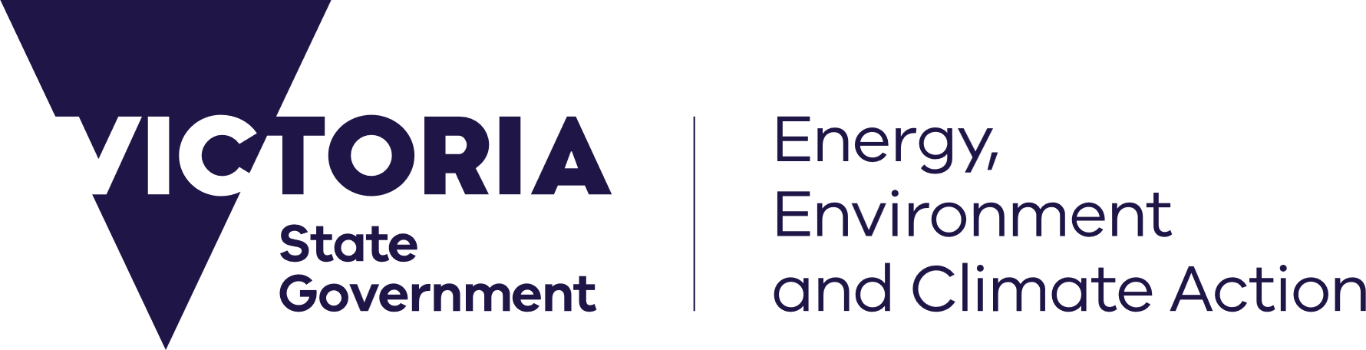


Position details
Position title: | Project Officer, Support to Comply
Position number: | 50969953
Classification: | VPS Grade 4
Salary range: | $100,894 – $114,476 plus superannuation
Employment type: | Fixed Term until 31 March 2027
Group: | Resources Victoria
Division & Branch: | Resources Victoria Approvals Coordination
Work location: | 8 Nicholson Street, East Melbourne  Hybrid work arrangement available: Yes No
Reports to: | Senior Project Officer, Support to Comply
Direct reports: | Yes No
Further information: | David Douglas via david.m.douglas@deeca.vic.gov.au or 0402 854 581
Position purpose
The Project Officer, Support to Comply supports delivery of the Support to Comply – Extending Benefits project, contributing to the development and implementation of guidance, policies and procedures for industry and regulators. The Project Officer supports Resources Victoria’s transition to a duty-based framework under the Minerals Resources (Sustainable Development) Amendment Act 2023.
Context
Resources Victoria’s mission is to facilitate informed and responsible earth resources exploration, development, extraction and rehabilitation in Victoria. This includes oversight of mining activities for critical minerals, gold and other metals, petroleum, coal, sand, rock and gravel.

Our priorities are to:
- Increase investment in Victoria’s earth resources, including new critical minerals.
- Build confidence in the performance of the earth resources sector in Victoria and its regulation.
- Secure the supply of quarry materials essential for new infrastructure.

We will deliver this by:
- Applying our specialist scientific and technical expertise to understand Victoria’s geology and create new opportunities for responsible investment.
- Delivering resources policy and legislative reform that enables responsible earth resources activities, from exploration through to rehabilitation.
- Facilitating earth resources projects in a timely and transparent way that safeguards public safety, human health, infrastructure and the environment.
- Working across government to enable investment, while supporting and regulating industry with expert advice and clear approvals processes.
Accountabilities
- Work with the Senior Project Officer to audit existing regulatory guidance and identify gaps and priority areas for development.
- Support the development of guidance materials and operating procedures to assist industry transition to a duty-based framework and align with Resources Victoria processes and policies.
- Assist with the publication and communication of guidance, policies and procedures for internal and external audiences.
- Build and maintain effective working relationships with internal and external stakeholders, including industry, to support project delivery.
- Support the collection, analysis and incorporation of stakeholder feedback to improve guidance materials and support their practical application.
- To practice cultural safety by creating environments, relationships and systems free from racism and discrimination so that people can feel safe, valued and able to participate.
Key Selection Criteria
The key selection criteria specified below outline the capabilities required for the position.
Specialist/Technical Expertise/Qualifications
- Strong written and verbal communication skills, with the ability to translate complex or technical information into clear, practical and user-friendly outputs.
- Experience working with stakeholders, including managing feedback and concerns, ideally with an understanding of regulatory or earth resources environments.
- Shows initiative, sound judgement and a willingness to learn, share knowledge and contribute to continuous improvement.
Capabilities
- Communicate with Impact: Prepares and delivers logical sequential and succinct presentations; Uses clear & concise language; Uses media appropriate to the audience and presents information to develop the understanding of the topic.
- Work Collaboratively: Build a supportive and cooperative team environment; Engages other teams to share information in order to understand or respond to issues; Support others in challenging situations.
- Critical Thinking and Problem Solving: Resolves issues through deep understanding or interpretation of existing guidelines. Where guidelines are not available, analyses ideas available and acts to resolve problems. If required, determine additional information needed to make informed decisions. Applies critical thinking and problem-solving concepts in the right context.
- Stakeholder Management: Takes steps to add value for the client or stakeholder; Links people with other areas as appropriate; Monitors client and stakeholder satisfaction; Constructively deals with stakeholder issues.
Position specific requirements
Financial Delegation Value | $0 A declaration of Private Interests will be required for positions with financial delegations of >$20,000
The occupational health and safety requirements of this position may include, but are not limited to: | - Sedentary desk work
DEECA will conduct relevant checks about applicants and the information provided within an application. Checks will include but are not limited to: | A Declaration and Consent form consenting to DEECA contacting current and previous employer(s) to substantiate employment history, past conduct and performance is required.  A satisfactory National Police Check will be required (for all non-DEECA employees).
Employment terms and conditions | Are governed by the Victorian Public Service Enterprise Agreement 2024 and the Public Administration Act 2004.  Recipients of Victorian Public Service (VPS) voluntary departure packages should note that re-employment restrictions apply.  Non-VPS applicants will be subject to a probation period of six months.
Privacy | The department affirms that the collection and handling of applications and personal information will be consistent with the requirements of the Privacy and Data Protection Act 2014.
About the Department
We employ approximately 6,300 staff, including around 600 seasonal staff, across more than 86 locations throughout Victoria, across energy, environment, climate action, water, agriculture, and resources portfolios.
Our challenge is to maintain Victoria’s liveability, with a population expected to almost double by 2050, while responding to climate change and protecting our natural environment, infrastructure and heritage for future generations. We take a community-centred approach and involve communities and key stakeholders in decisions and policies that affect them and we collaborate across our portfolios to design and deliver services and programs.

For further information about the department, please visit our website www.deeca.vic.gov.au
Our values
Our values align with the core Public Sector values – responsiveness, integrity, impartiality, accountability, respect, leadership and human rights. Additionally, we use our Leadership Model to shape the way we work. Using the principles of ‘Work Together’, ‘Do What Matters’ and ‘Make a Difference’ we create a culture that puts our people at the centre of everything we do. The Leadership Model reminds us of what’s important in our daily interactions with each other, and in the actions and decisions we take to deliver our work
Our Community Charter
We are committed to the Victorian Government Public Engagement Framework that enables meaningful and inclusive engagement to make better decisions and improve the lives of Victorians. Our Community Charter is our promise to be available, be involved and listen, and take action as we deliver services and create opportunities that supports thriving, productive, and sustainable communities, environments and industries.
Emergency Response and Health and Safety Requirements

The department plays a major role in Victoria’s emergency response activities, through an all-hazards, all-emergencies approach. Staff may be directly employed for these roles or may be called upon to support these activities as required following the appropriate training and “fit for work” assessment.
A Diverse, Inclusive and Flexible Workplace
DEECA welcomes applicants from a diverse range of backgrounds, and we focus on the essential requirements of the job and being consistent and fair in our treatment of all applicants. Our diversity and inclusion outcome pillars:
1. We are connected to liveable, inclusive, sustainable communities
2. We are diverse
3. We are inclusive and flexible
4. We are safe and respectful
DEECA can provide reasonable adjustments for people with a disability. If you need assistance to fully participate in the application or interview process, please use the contact listed under ‘Position Details’.
Aboriginal Cultural Safety
Cultural safety of Traditional Owners and Aboriginal Victorians, as an underpinning principle of self-determination, is embedded in everything we do. Under the Aboriginal Cultural Safety Framework DEECA is committed to creating a culturally safe workplace, where there is space for culture to live and for spiritual and belief systems to exist. For further information, please contact aboriginal.employment@deeca.vic.gov.au.
Balancing your Life / Hybrid Working
We understand that a balanced life is important to our employees and we offer a wide range of flexible options to help you manage family, health, carer responsibilities, study, career or personal interests. Options may include working some days from home or other suitable locations, starting early or late, working part time, job share or accessing paid or unpaid leave in line with our flexible working policy.
To receive this information in an accessible format (such as large print or audio) please call the Customer Service Centre: 136 186, TTY: 133 677, or email customer.service@deeca.vic.gov.au

